**Practical:10**

**Aim: Software Demo-Total ERP.**

# ****Total ERP:****

# **Total ERP Software is designed to be a complete solution for business today Total ERP comes complete with the full sets of software in every installation.**

# **Total ERP software include the following areas –**

# **Different Modules of Total ERP are as follows**

# **Accounts**

# **Appointments**

# **Banking**

# **Budget**

# **CRM**

# **Delivery**

# **Employee**

# **Fixed Assets**

# **General**

# **Hire**

# **Hospitality**

# **Inventory**

# **Manufacturing**

# **Payments**

# **Payrolls**

# **Purchases**

# **Sales**

# **Utilities**

# **Work shops**

# ****Accounts:****

* **ERP Software** gives you maximum flexibility from the creation of your Chart of Accounts and Cost Centres to Real Time Reporting and easy to use Graphical presentation of data.
* Transparency of data is crucial to understand your accounts. **ERP Software** provides drillable information throughout its extensive reports.
* Drill into your Balance Sheet or Profit & Loss down to individual transactions in real time. Full Audit Trail is provided to track all transactions ensuring data integrity.

# Description: C:\Users\Malakar\Pictures\vlcsnap-2012-10-27-12h21m39s66.png

It includes

* Account
* BAS Report
* Journal Entry
* Account Type List
* Profit And Loss
* Balance Sheet
* Accounts List
* BAS Report List
* Journal Entry List
* Summary Sheet
* Trial Balance
* Accounts Report

### Trial Balance:

* Run a trial balance or General Ledger at any time as required. As ERP Software is a true real time system, any transaction that has been created will appear on the report instantly.

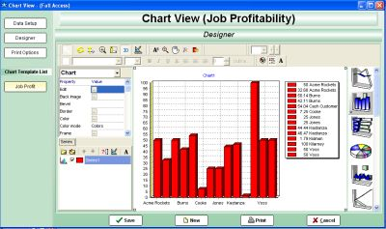

### BAS Report:

* Instant BAS report printout. Preloaded with the correct codes, just requires date selection to load the numbers.
* If running multiple companies in the one file, you can create either a BAS or VAT report on the group of companies or an individual BAS/VAT report per company. BAS or VAT reports are also fully drillable allowing you to see the transactions that make up the field.

### Summary Report:

* Look at a simple one page snapshot of your business, including cash in bank, accounts receivable, accounts payable, sales of different periods, cost of different periods and profit and loss over different periods.
* All figures again within this report are fully drillable to further investigate how these values are created.

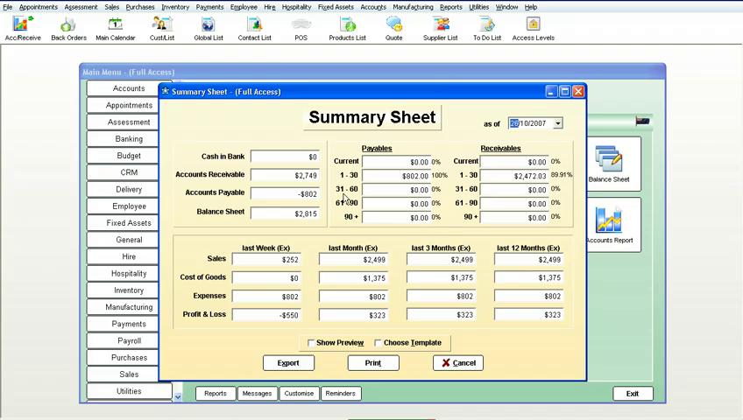

# **Customer Relationship Management (CRM):**

# Description: C:\Users\Malakar\Pictures\vlcsnap-2012-10-27-12h44m36s10.png

**ERP Software** provides CRM solutions for both Sales Force Automation and operational CRM.

### Other Contact

* Canvasser
* Source List
* Contact Selection Range
* Marketing Contact
* Marketing
* Other Contact List
* Canvasser List
* Feedback List
* Contact Selection Range List
* Marketing Contact List
* CRM Reports
* Mail Merge
* Loyalty Program
* Product Reward Points List

### Mail Merge:

* **ERP Software** has the facility to send mail merge documents to prospects, leads and customers based on nearly infinite selections.
* With our built in email and fax engines, the sending of documents takes seconds, not hours. An extremely powerful marketing tool!

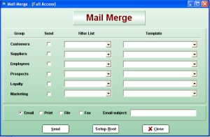

### Loyality Programmes:

* **ERP Software** has the facility to send mail merge documents to prospects, leads and customers based on nearly infinite selections. With our built in email and fax engines, the sending of documents takes seconds, not hours. An extremely powerful marketing tool!

### Contact:

* Complete details as required to keep an accurate customer database, which can be added to, or deleted from, depending on your requirements.
* The customer database is live to all areas of **ERP Software** which ensures that if any transaction involving a client is processed, the correct details including credit limits, pricing levels, past history, and contact and shipping details are automatically loaded and updated.
* No longer do you have to have multiple software packages to run your business.

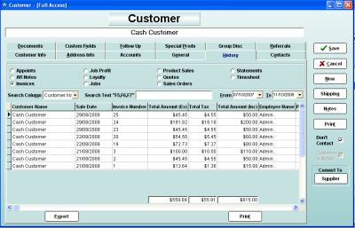

### Contact List:

* Keeps a list of all contacts associated with the customer, which can be added to, or deleted from depending on your requirements.

### Marketing Contact Listing

### Employees:

* Complete details as required, to keep an accurate and extensive employee database or collection of information that is fully integrated with a complete business management and accounting system.
* This collection of information can be added to or deleted from depending on your requirements, even down to creating your own customisable fields and drop downs.

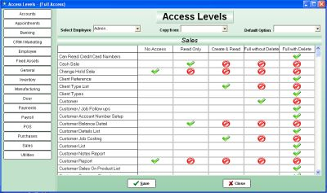

### Rosters:

* ERP Software has a fully integrated roster module, not only is it attached to the Employee, but it can be directly loaded from the roster into Payroll.
* Assign all forms of leave on the roster, such as sick and annual leave, for any or all employees, which again will flow, directly into payroll.
* Great for tracking which store and what times staff need to be at work.

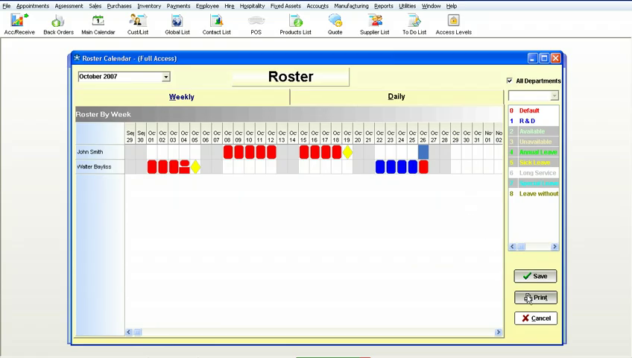

### To Do List:

* Tasks can be assigned to different employees, who when logging on to their system, a screen will pop up to remind them to complete these tasks.
* These can be viewed and alter at any time and also reported on.

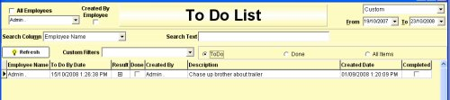

### Customise Reports:

* Add your own specific fields to categorise your Employees. These fields can be text fields as well as 'Drop Down' fields.
* By making them drop downs you force a certain value to be selected, thus making your database consistent with what is displayed.
* There is even an option that you can turn on or off, with these fields that prevents the form from being closed if one of the values has not been entered.

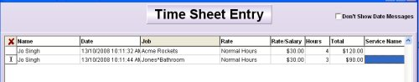

### Personal Preferences:

* Allows each employee to set their own personal preferences, without accessing vital data, or areas of 'No Access'.
* They can completely customise the way ERP Software looks for them even down to which fields the cursor stops on, including colours displayed and columns on reports that are seen.

### Representative Listing:

* Complete details as required, to keep an accurate Rep/Trainer database, a database or collection of information, that is fully integrated with a complete business management and accounting system, including a full calendar display screen, showing appointments and meetings for each and every Rep/Trainer
* This collection of information can be added to or deleted from depending on your requirements, even down to creating your own customisable fields and dropdowns.

# Inventory:

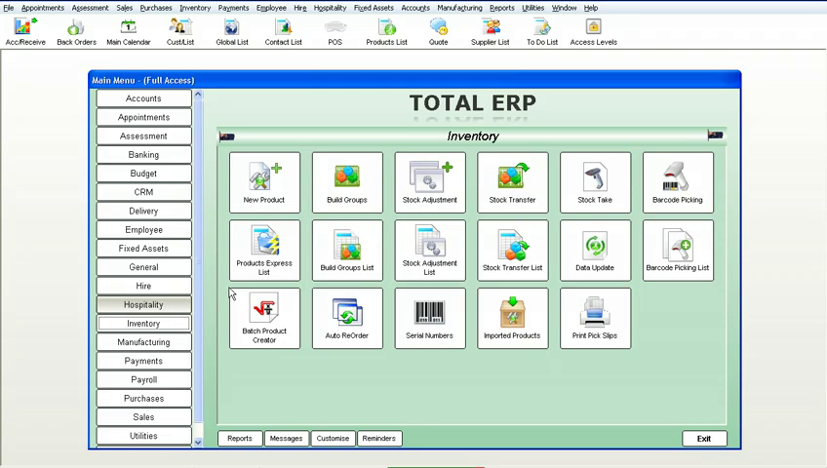

Features of  ERP Software's Inventory Management include the following:

* New Product
* Build Groups
* Stock Adjustment
* Stock Transfer
* Stock Take
* Barcode Picking
* Product Express List
* Build Group List
* Stock Adjustment List
* Stock Transfer List
* Data Update
* Barcode Picking List
* Batch Product Creator
* Auto ReOrder
* Serial Numbers
* Imported Products
* Print Pick Slips

### Barcode Picking:

* This module of **ERP Software** allows orders to be placed in the office, the warehouse then completes the order without touching the computer, by the use of a scanner.
* By scanning in their employee barcodes, the next prioritised picking slip will appear. **ERP Software** will then track how long it takes to pick the goods, and then how long it takes to pack the goods

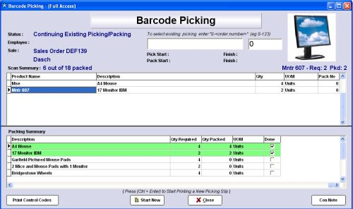

### Build Groups:

* Also called a "Bill of Materials". This is where you can make a product from different, separate products. You can also have a group within a group or unlimited sub-products.
* No limits. Whenever one of these groups is sold, all the associated separate products are reduced by the number in the stock on hand list required to make the group.

### Product Express List:

* Complete details as required, to keep an accurate and extensive stock management database, even down to creating your own customisable fields and drop downs.
* Fully drillable allowing you to retrieve any information on a product down to an amazing detail level.

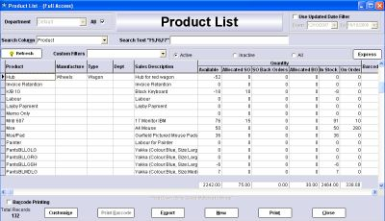

### Stock Transfers:

* Keeps a complete record of any stock transfers between warehouses, stores etc. will even track who did what transfer, and at what time they did it.

### Serial Number:

* Individual products can be tracked from purchasing to sales, with their own separate numbers.
* Keeps accurate records of exactly which customer has which product, when they brought it and who the supplier was that supplied it. Great for warranties etc.

### Data Updates:

* Prices can be altered on mass with the push of one button, by Department, Code, Group, etc. You can set adjustments as a fixed value or as a percentage change, as a positive or a negative.
* If you turn on a preference in **ERP Software**, any product cost change will automatically adjust the sell price, keeping the same margin as before the cost change.

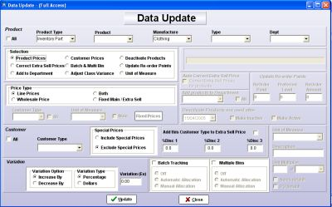

### Stock Adjustments:

* Great for adjusting stock due to theft, lost stock or unknown.
* Simply assign it to an adjustment account and your stock balances and chart of account are kept accurate to the second.

**Stock Take:**

* These can be done by a number of methods. 1. Directly entering the count into the program. 2.
* By exporting out to Microsoft Excel and adjusting the spreadsheet in Microsoft Excel, then importing the spreadsheet back into **ERP Software** and assigning an adjustment value account. 3.
* By the use of a handheld unit, this will interface directly with **ERP Software**. With the addition of a scanner, stock takes become a breeze to do and what would normally take a team of people eight hours to complete, can be accomplished in less than two hours with the scanner unit.

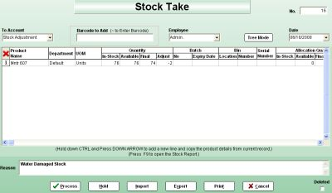

**Employee:**

* **ERP Software** helps you measure and increase employee productivity.
* Real Time integration of  Jobs, Sales, Timesheets and Rosters within ERP Software means you can track, measure and respond immediately to fine tune employee activities .

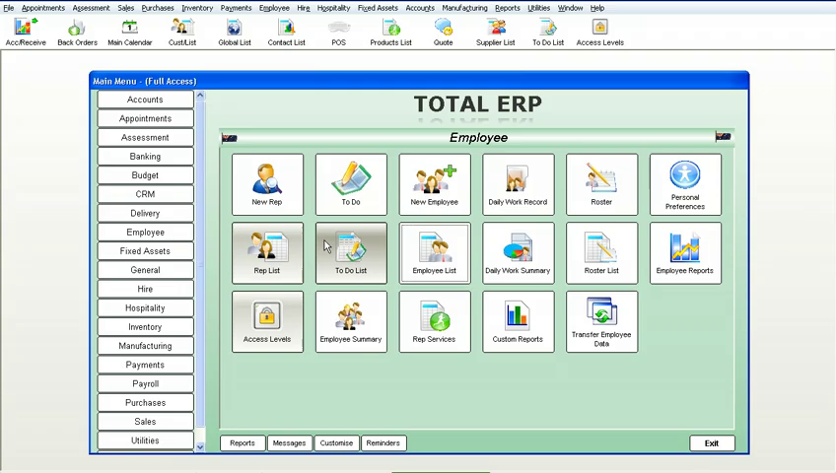

It includes

* New Rep
* To Do
* New Employee
* Daily Work Report
* Roster
* Personal Preference
* Rep List
* To Do List
* Employee List
* Daily Work Summary
* Roster List
* Employee Reports
* Access Levels
* Employee Summary
* Rep Service
* Custom Reports
* Transfer Employee Data

### New Employees:

* Complete details as required, to keep an accurate and extensive employee database or collection of information that is fully integrated with a complete business management and accounting system.
* This collection of information can be added to or deleted from depending on your requirements, even down to creating your own customisable fields and drop downs.



### Rosters:

* ERP Software has a fully integrated roster module, not only is it attached to the Employee, but it can be directly loaded from the roster into Payroll.
* Assign all forms of leave on the roster, such as sick and annual leave, for any or all employees, which again will flow, directly into payroll. Great for tracking which store and what times staff need to be at work.



### To Do List:

* Tasks can be assigned to different employees, who when logging on to their system, a screen will pop up to remind them to complete these tasks. These can be viewed and alter at any time and also reported on.



### Customise Reports:

* Add your own specific fields to categorise your Employees. These fields can be text fields as well as 'Drop Down' fields.
* By making them drop downs you force a certain value to be selected, thus making your database consistent with what is displayed.
* There is even an option that you can turn on or off, with these fields that prevents the form from being closed if one of the values has not been entered.



### Personal Preferences:

* Allows each employee to set their own personal preferences, without accessing vital data, or areas of 'No Access'.
* They can completely customise the way ERP Software looks for them even down to which fields the cursor stops on, including colours displayed and columns on reports that are seen.

### Representative Listing:

* Complete details as required, to keep an accurate Rep/Trainer database, a database or collection of information, that is fully integrated with a complete business management and accounting system, including a full calendar display screen, showing appointments and meetings for each and every Rep/Trainer. This collection of information can be added to or deleted from depending on your requirements, even down to creating your own customisable fields and dropdowns.

**Sales:**

* **ERP Software** gives you maximum flexibility, combined with rock solid control over every aspect of your sales processes and cycles from the very first contact with a prospect, all the way through to them becoming a customer.

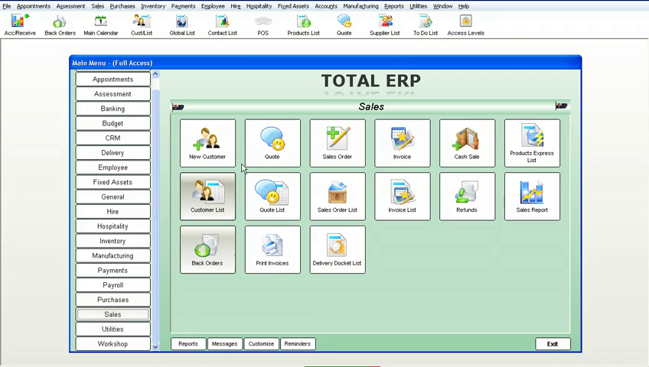

* New Customer
* Quote
* Sales Order
* Invoice
* Cash Sale
* Product Express List
* Customer List
* Quote List
* Sales Order List
* Invoice List
* Refunds
* Sales Reports
* Back Orders
* Print Invoice
* Delivery Docket List

### Customers:

* Complete details as required to keep an accurate customer database, which can be added to, or deleted from, depending on your requirements.
* The customer database is live to all areas of **ERP Software** which ensures that if any transaction involving a client is processed, the correct details including credit limits, pricing levels, past history, and contact and shipping details are automatically loaded and updated.
* No longer do you have to have multiple software packages to run your business.

### Customer List:

* An extensive and complete history of every quote, sales order, invoice, cash sale, statement, appointment etc that you have made with this customer.
* These can at any time be simply drilled into to open the original transaction that makes up the report.
* If you have the phone system connected to **ERP Software** this list will even include calls made to the customer.

### Quotes:

* Unlimited number per individual customer or job, with one button conversion to invoice, sales order, repair, another quote, or smart order.
* Any special price quoted on for a customer can be automatically stored and always used as that customer's price for that product.
* Can be faxed, emailed, or printed in multiple formats, all from the quote screen, as**ERP Software** has it's own built-in fax and email engine, so no external software is required to complete these operations.

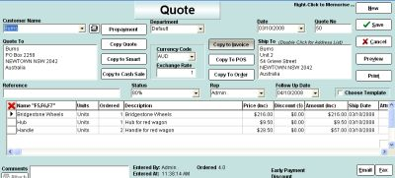

### Quote List:

* Estimate sales by judging how likely obtaining the quote is, by using the status options to reflect the likelihood of making the sale.

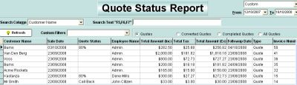

### Sales Orders:

* Used as a confirmation of a sale prior to invoicing. **ERP Software** sales orders come with full picking slip and delivery docket capacity. These can also be easily converted to any number of options from invoices to smart orders etc.

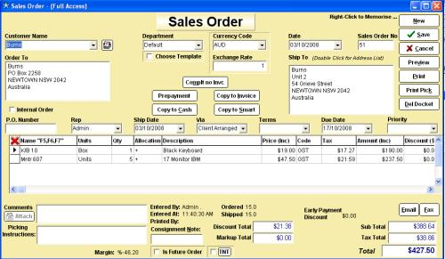

### Cash Sales:

* Can be faxed, emailed or printed in multiple formats, all from the cash sale screen, as **ERP Software** has its own built-in fax and email engine, so no external software is required to complete these operations

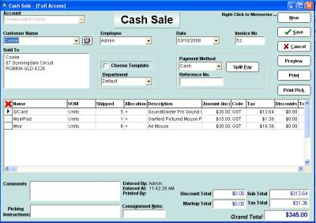

### Invoicing:

* Can be faxed, emailed or printed in multiple formats, all from the invoice screen. As **ERP Software** has its own built-in fax and email engine, no external software is required to complete these operations.

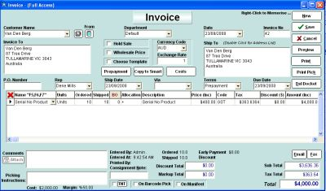

### Refunds:

* Can be faxed, emailed or printed in multiple formats, all from the refunds screen, as **ERP Software** has its own built-in fax and email engine, so no external software is required to complete these operations.

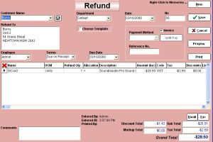

### Delivery Dockets:

* Complete printout of all the information as required for the delivery of the customers goods.

# Workshop:

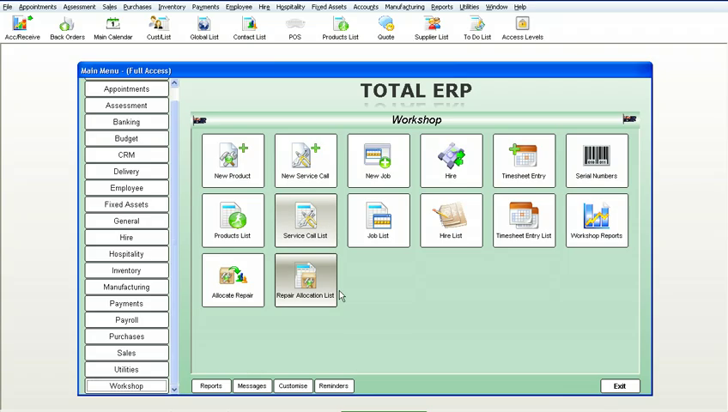

* ERP Software gives you enormous flexibility and maximum control in managing all aspects of your workshop, servicing and maintenance requirements, from tracking warranty costs, on-site calls to automated scheduled servicing.  ERP is fully integrated to track all of your servicing inputs including parts, time and labour.
* New Product
* New Service Call
* New Job
* Hire
* Time sheet Entry
* Serial Numbers
* Product List
* Service Call List
* Job List
* Hire List
* Timesheet Entry List
* Workshop Reports
* Allocate Repairs
* Repairs Allocation List

### Repair Allocation List:

* Book in repair work with a client, internally or externally, these can be warranty or service calls etc.  Also track repair work for assets you own, rent or hire giving a complete breakdown of all costs involved with keeping that asset.

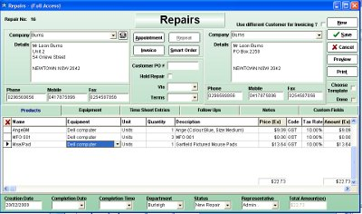

### Workshop Report:

* Full workshop management with reports including work-in-progress, staff costing, job costing, job profitability and stock control with the ability to barcode-scan in stock used for the jobs in the workshop.  Stock can be automatically ordered from the repair.

### 

### Serial Number:

* Serial number tracking is active on all repairs allowing you to track full history on repaired items and warranty periods on any item.

### Time Sheets:

* Fully integrated with time sheet entries and payroll.  Great for tracking hours spent on jobs within the system.

